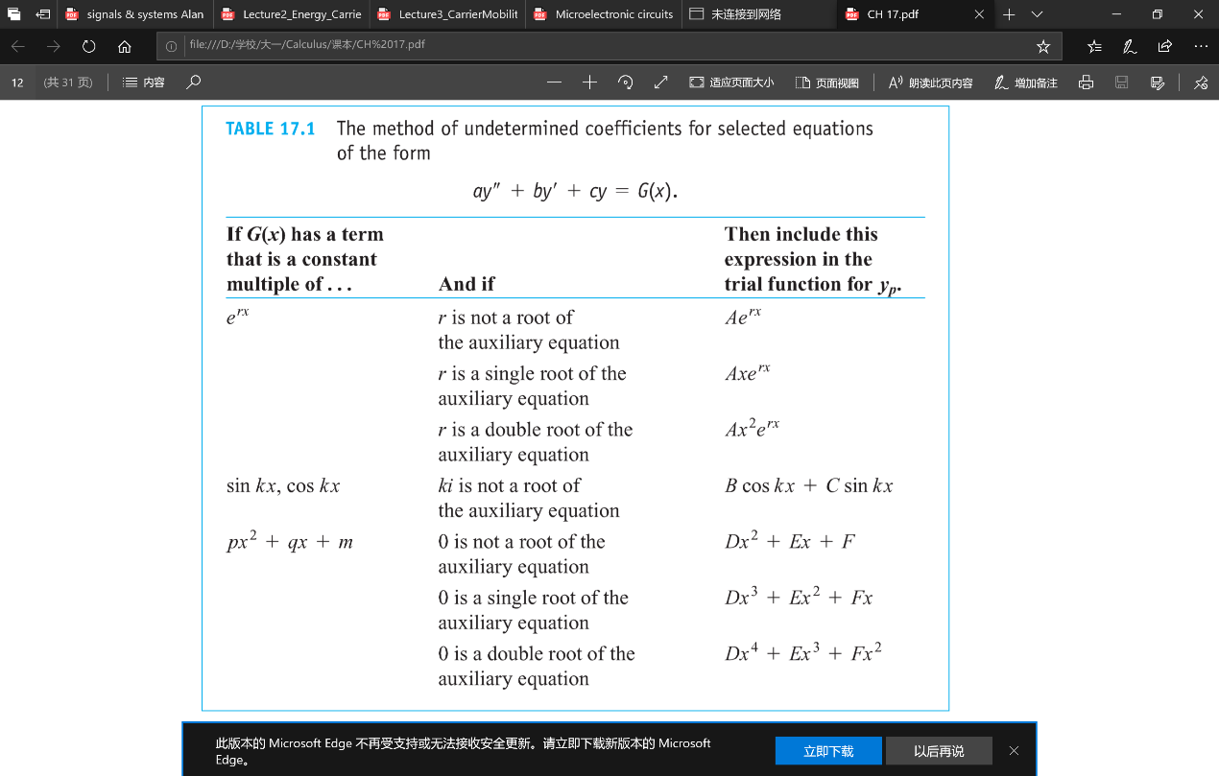

**诱导公式**

$\sin\left(2kπ+α\right)=\sin{α}$ $\cos\left(2kπ+α\right)=\cos{α}$ $\sin\left(-α\right)=-\sin{α}$ $\cos\left(-α\right)=\cos{α}$ $\sin\left(π-α\right)=\sin{α}$ $\cos\left(π-α\right)=-\cos{α}$ $\sin\left(π+α\right)=-\sin{α}$ $\cos\left(π+α\right)=-\cos{α}$ $\sin\left(\frac{π}{2}-α\right)=\cos{α}$ $\cos\left(\frac{π}{2}-α\right)=\sin{α}$ $\sin\left(\frac{π}{2}+α\right)=\cos{α}$ $\cos\left(\frac{π}{2}+α\right)=-\sin{α}$ $\operatorname{tg}\left(kπ+α\right)=\operatorname{tg}{α}$ $\operatorname{tg}\left(-α\right)=-\operatorname{tg}{α}$ $\operatorname{tg}\left(π-α\right)=-\operatorname{tg}{α}$ $\operatorname{tg}\left(π+α\right)=\operatorname{tg}{α}$ $\operatorname{tg}\left(\frac{π}{2}-α\right)=\operatorname{ctg}{α}$ $\operatorname{tg}\left(\frac{π}{2}+α\right)=-\operatorname{ctg}{α}$

**Continuous-time periodic square wave连续时间方波**

$$x\left(t\right)=\left\{\begin{aligned}&1&\left|t\right|<T_{1}& \\ &0 &T_{1}<\left|t\right|<\frac{T}{2}&\end{aligned}\right. a_{k}=\frac{1}{T}\int_{-T_{1}}^{T_{1}}{e^{-jkω_{0}t}}dt=\left\{\begin{aligned}&\frac{2T_{1}}{T} &k=0 \\ &-\frac{e^{-jkω_{0}T_{1}}-e^{jkω_{0}T_{1}}}{jkω_{0}T} &k≠0&\end{aligned}\right.=\left\{\begin{aligned}&\frac{2T_{1}}{T} &k=0& \\ &\frac{\sin\left(kω_{0}T_{1}\right)}{kπ} &k≠0&\end{aligned}\right.$$

**Discrete-time periodic square wave离散时间方波 $x\left[n\right]=1 for-N_{1}≤n≤N_{1}$**

When $k=0, ±N, ±2N, …$, $a_{k}=\frac{1}{N}\sum_{n=<N>}{x\left[n\right]e^{-jkω_{0}n}}=\frac{1}{N}\sum_{n=-N_{1}}^{N_{1}}{e^{-jk\frac{2π}{N}n}}=\frac{1}{N}\sum_{n=-N_{1}}^{N_{1}}{1}=\frac{2N_{1}+1}{N}$

When $k≠0, ±N, ±2N, …$, $a_{k}=\frac{1}{N}\sum_{n=<N>}{x\left[n\right]e^{-jkω_{0}n}}=\frac{1}{N}\sum_{n=-N_{1}}^{N_{1}}{e^{-jkω_{0}n}}=\frac{1}{N}e^{jk\frac{2π}{N}N_{1}}\frac{1-e^{-jk\frac{2π}{N}\left(2N_{1}+1\right)}}{1-e^{-jk\frac{2π}{N}}}=\frac{1}{N}\frac{\sin\left(\frac{2kπ\left(N_{1}+\frac{1}{2}\right)}{N}\right)}{\sin\left(\frac{kπ}{N}\right)}$

化简技巧 $1-e^{-jk\frac{2π}{N}}=e^{-jk\frac{2π}{2N}}\left(e^{jk\frac{2π}{2N}}-e^{-jk\frac{2π}{2N}}\right)$

**等比数列**

通项公式： $a_{n}=a_{1}q^{n-1}$

两项关系： $a_{n}=a_{m}q^{n-m}$

求和公式： $S_{n}=a_{1}\frac{a-q^{n}}{1-q}=\frac{a_{1}-a_{n}q}{1-q}$

**Convolution卷积**

$$y\left[n\right]=\sum_{k=-∞}^{∞}{x\left[k\right]h\left[n-k\right]}=\sum_{k=-∞}^{∞}{x\left[n-k\right]h\left[k\right]} \\ y\left(t\right)=\int_{-∞}^{+∞}{x\left(τ\right)h\left(t-τ\right)dτ}\int_{-∞}^{+∞}{x\left(t-τ\right)h\left(τ\right)dτ}$$

一个函数的 $t$ 换成 $τ$，另一个函数的 $t$ 换成 $t-τ$；如果结果以原点为界，记得写成 $u\left[n\right]u\left(t\right)$ 的形式； $x\left(τ\right)$ 的图像正常， $h\left(t-τ\right)$ 的图像关于 $y$ 轴翻转后，原点为 $t$

**Singularity functions**

$u_{k}\left(t\right)$ 求导； $u_{-k}\left(t\right)$ 积分； $u_{1}\left(t\right)$ 是unit doublet

**Even and odd decomposition**

$$\operatorname{Ev}\left\{x\left[t\right]\right\}=\frac{1}{2}\left\{x\left(t\right)+x\left(-t\right)\right\} \\ \operatorname{Od}\left\{x\left[t\right]\right\}=\frac{1}{2}\left\{x\left(t\right)-x\left(-t\right)\right\}$$

奇分解围绕原点旋转除2，偶分解围绕y轴变换除2

|  |  |  |
| --- | --- | --- |
| **系统性质的判据** | 输入输出关系 | 单位冲激响应 |
| Memoryless | Output at $t=t_{0}$ depends only on the value of input at $t=t_{0}$ | $h\left(t\right)=0$ for $t≠0$ |
| Invertible | There exist an inverse system | $∃h_{1}\left[n\right] s.t. h\left[n\right]*h_{1}\left[n\right]=δ\left[n\right]$ |
| Causality | Output at this time only depends on values of the input at the present time and in the past | $h\left[n\right]=0$ for $n<0$ |
| Stability | BIBO |  |
| Time-invariance | Let $x_{1}\left(t\right)=x\left(t-t_{0}\right)$ Check $y_{1}\left(t\right)=?y\left(t-t_{0}\right)$ | Must satisfy |
| Linearity | Let $x_{1}\left(t\right), x_{2}\left(t\right), x_{3}\left(t\right)=x_{1}\left(t\right)+x_{2}\left(t\right)$ Check $y_{3}\left(t\right)=?ay_{1}\left(t\right)+by_{2}\left(t\right)$ | Must satisfy |

**Fourier Series傅里叶级数**

|  |  |
| --- | --- |
| $$x\left(t\right)=e^{st}\underset{→}{ LTI }y\left(t\right)=H\left(s\right)e^{st}$$ $$\sum_{k}{a_{k}e^{s_{k}t}}\underset{→}{ LTI }\sum_{k}{a_{k}H\left(s_{k}\right)e^{s_{k}t}}$$ | $$x\left[n\right]z^{n}\underset{→}{ LTI }y\left[n\right]=H\left(z\right)z^{n}$$ $$\sum_{k}{a_{k}z_{k}^{n}}\underset{→}{ LTI }\sum_{k}{a_{k}H\left(z_{k}\right)z_{k}^{n}}$$ |
| $$H\left(s\right)=\int_{-∞}^{∞}{h\left(t\right)e^{-st}}dt \\ H\left(jω\right)=\int_{-∞}^{∞}{h\left(t\right)e^{-jωt}}dt$$ | $$H\left(z\right)=\sum_{k=-∞}^{∞}{h\left[k\right]z^{-k}} \\ H\left(e^{jω}\right)=\sum_{n=-∞}^{∞}{h\left[n\right]e^{-jωn}}$$ |
| $$x\left(t\right)=\sum_{k=-∞}^{∞}{a_{k}e^{jkω_{0}t}}$$ $$a_{k}=\frac{1}{T}\int_{T}{x\left(t\right)e^{-jkω_{0}t}}dt$$ | $$x\left[n\right]=\sum_{k=<N>}{a_{k}e^{jkω_{0}n}}$$ $$a_{k}=\frac{1}{N}\sum_{n=<N>}{x\left[n\right]e^{-jkω_{0}n}}$$ |

**Impulse train**

$$x\left(t\right)=\sum_{k∈R}{δ\left(t-kT\right)}\underset{↔}{FS}a_{k}=\frac{1}{T}\int_{-\frac{T}{2}}^{\frac{T}{2}}{δ\left(t\right)e^{-jkω_{0}0}}dt=\frac{1}{T}$$

**Properties of convolution卷积的性质**

$$x\left(t\right)*δ\left(t\right)=x\left(t\right) \\ x\left(t\right)*δ\left(t-t_{0}\right)=x\left(t-t_{0}\right) \\ x\left(t-t_{1}\right)*δ\left(t-t_{2}\right)=x\left(t-t_{1}-t_{2}\right) \\ x\left(t\right)*δ^{'}\left(t\right)=x^{'}\left(t\right) \\ x\left(t\right)*u\left(t\right)=x^{-1}\left(t\right)=\int_{-∞}^{t}{x\left(τ\right)dτ} \\ x\left(t\right)*h\left(t\right)=x^{'}\left(t\right)*h^{-1}\left(t\right)$$

**Euler’s formula欧拉公式**

$$e^{jθ}=\cos{θ}+j\sin{θ} \\ \cos{θ}=\frac{e^{jθ}+e^{-jθ}}{2} \\ \sin{θ}=\frac{e^{jθ}-e^{-jθ}}{2j}$$